TITLE: How to create efficient relational database for a bookstore

Purpose

The purpose of the database for the bookstore named Freezystore is to store and organize information related to the bookstore's inventory, customers, and sales. The database would be used to track the bookstore's inventory levels and reorder books as needed, track customer information and purchase history for targeted marketing and loyalty program purposes and generate sales reports for the bookstore's management team.

Introduction

A functional database is an essential tool for managing a bookstore's inventory, tracking customer information, and generating reports. The process of creating a functional database for a bookstore involves several steps, including defining the purpose and scope of the database, choosing a database management system, designing the database schema, creating tables and fields, populating the database with data, testing, and optimizing the database, maintaining, and updating the database. By following these steps, a bookstore can create a functional database that is well-organized, efficient, and secure, allowing it to better manage its operations and serve its customers. This project capture the stages involved in creating operational database, these stages are listed and explain below;

Create and a select a database

The first step is choosing a database management system, there are different types of relational database, for this project we will be creating and writing syntax on MySql. This is done by creating a connection on MySql, then create a database using the following syntax



Then select the database using



Creating tables and fields

A table in MySQL is a database object that stores data in rows and columns, similar to a spreadsheet. Each table has a specific structure defined by the columns and their data types and can have various constraints and indexes applied to it to improve performance and data integrity. Tables can be queried, updated, and modified using SQL commands.

Six tables were created for freezystore: "books", “employees”, “suppliers”, “supplies”, “sales” and "customers”; and they are all connected , see below for the syntax used to create the table for “sales”, similar approach was used to create other tables ;

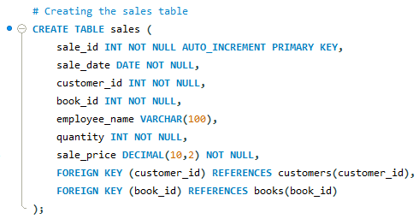

Populating the database with data

There are several ways to populate a database with data, one method is to use SQL syntax to insert data or manually write database management toll or programmatically by writing a scripting language such as python or java to generate and execute the SQL statement(either by creating forms with this languages), Additionally, data can be populated into the database through ETL (Extract, Transform, Load) process, where data from various sources are extracted, transformed to fit the target database structure and loaded into the target database.

All the tables created in freezystore database was populated with the use of structured query language.

Optimizing the database

Views and triggers were used to optimize the performance and efficiency of a database ‘freezystore’. Views are virtual tables that are based on the result of a SELECT statement, Triggers are special types of stored procedures that automatically execute when an insert, update, or delete operation occurs on a specified table or view. They can be used to enforce data integrity, maintain data consistency, or perform auditing or logging.

A view that checks the list of books where the stock is less or equal to 5 was created, this function can be access without writing any form of complex query once a view has been created address the task.

A trigger that updates the books stock was created, basically Sql query that update the stock whenever there is sales or order. Then the view created above can be queried to know the stock left so that the store will not run out of stock before replacement. The trigger includes the use different commands such as create, insert, update, join. see the trigger syntax below:

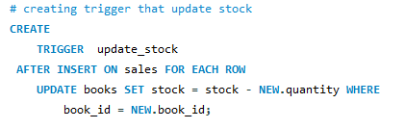

Testing and Troubleshooting:

After the tables were created and data was inserted, the database was tested by running different queries to ensure that the data can be retrieved and displayed correctly.

Conclusion:

The database for FreezyStore has been successfully created and set up. The tables have been created and populated with sample data. The database has been tested to confirm all optimization is working as expected and is ready for use. information’s in the schema can be update as need arises.